Action and Outreach Unit Report for Autumn Council 3/10/12 October

A big thank you to all our members for supporting our projects effectively and helping to make a difference for so many people across Manchester Diocese.

1. Students’ Welcome Week

Our members worked very hard at St Peter’s Chaplaincy, Oxford Road, from Thursday September 13th to Thursday September 21st.

Timetable
Thursday | Unpack and sort donations  Start bagging up ( 1000 bags done)
Friday | Bagging up  Soup and rolls and gift bags for international Students from Manchester Metropolitan University  Clear the Oxford Room, remove all rubbish and carry completed bags to various storage areas upstairs
Saturday | International Student Day – Manchester University  Soup and rolls  Bag distribution
Monday –  Thursday | Complete bagging up ( Monday morning) TOTAL = 2400  Soup and rolls for students  Bag distribution

We had an amazing generous response from our branches. Surplus teabags and biscuits have gone to good homes – Chaplaincy (for students), Rochdale Food Bank and the Booth Centre.
The product we gave out looked good and was well received by the students
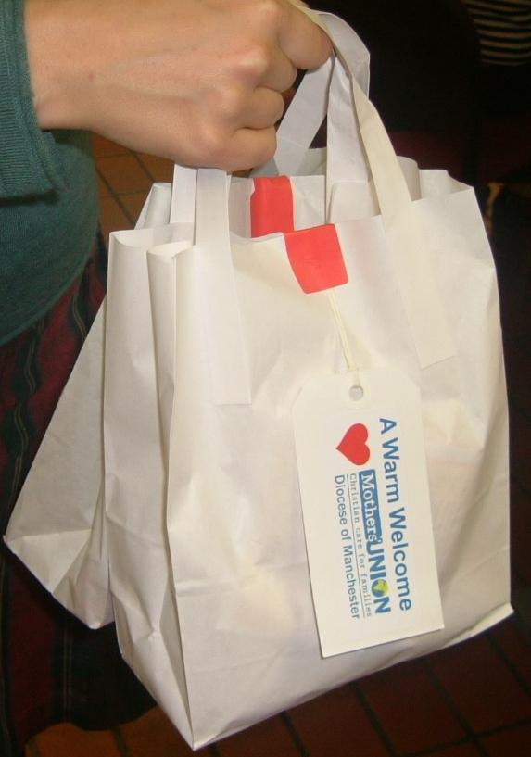

Many thanks to all members who donated items,
and a huge thanks to all the Mothers’ Union
volunteers who worked so hard to make the
week a success. Thanks also go to members of
the Chaplaincy team for their practical help.

After successfully organizing Welcome Week for
six years, Margaret Morris has decided to pass
on this job to others. However, I am very pleased
to report that Margaret will continue to organize
the Wednesday soup rotas and intends to help
out at Welcome Week. Margaret has done an
amazing job at the Chaplaincy and hopefully knows how much her hard work and input is appreciated.

Next year Chris Haworth and Angela Dand will be responsible for organizing the bagging up preparations. We shall collect exactly the same items as for 2012.

2. AFIA
Mothers’ Union has funded two holidays this year :
- a caravan holiday with Haven
- a short- break at a bed and breakfast in St Anne’s
AFIA has also agreed to part fund three inner city parishioners so they can take part in a parish trip to Spring Harvest in 2013.

3. Prisons
- Four volunteers have applied to work with the joint TfF (Time for Families) /Mothers Union parenting project at Forest Bank Prison, Salford. Christine Sharp ( Parenting co-ordinator) is one of the volunteers. She is about to work with TfF at Drake Hall women’s prison in Staffordshire.

- Every other month, I attend a Family Links meeting at the HMP Manchester Training Unit. These meetings are very informative and include representatives from the Prison Officers, Mental Health services, the Visits Centre manager, the volunteers Co-ordinator, POPs ( Partners of Prisoners and Families Support Groups) Home Start and Out There.

- Christine Sharp is meeting with staff at HMP Manchester to explore the possibility of setting up parenting courses at the prison.
Thanks to Home-Start, Christine was able to receive a day’s “Hidden sentence”
training in the summer.

- Our first prison volunteers should have filled in their CRB checks and given them in at HMP Manchester, so we can finally get this off the ground.

- Trustees have agreed to fund thirty Christmas Selection boxes for Prisoners’ children at the December Family Day at Manchester Prison.

4. Virtual babies

This is very much Jennifer White’s baby. The project at Status in Middleton is going from strength to strength. Those of us who attended the Evening of Celebration at Bolton and heard Jackie (from Status) speak will appreciate what a powerful and effective mentor she is for troubled teenagers and the difference she is determined to make in all matters to do with teenage pregnancy.

5. Hostels
The Christmas presents for hostels project is under way. Marion Ball provided everyone with an up to date list of hostels and all necessary details at the Action and Outreach Committee meeting on Thurs 23rd October.

6. Hospitals.
Another busy year with us needed more than ever with the NHS cuts Fairfield, Rochdale, Trafford and Hope have now closed their maternity units leaving us with the
HOSPITAL LINK PERSON and CONTACT NUMBER
Wythenshawe - Barbara Pye 0161 747 0269
Oldham - Ione Genty 0161 652 0914
Bolton - Jenny Murphy 01204 594539
St Mary’s, Manchester - Ann Smith 0161 652 0914
North Manchester – Neo Natal - Freda Horrocks 0161 682 6001
North Manchester - Neo Natal - Barbara Hill 0161 658 0482
North Manchester - Maternity - Lynne Longworth 01706 829062
Tameside - Violet Bradshaw 0161 370 0546
following hospitals:

These Link people take items in, and know what each hospital wants making. It is a waste of everyone’s time and money to make items they can’t use. The Link people should have knitting patterns too, if not please ring me.

We desperately need you to knit small white teddy bears, which are given to sick babies and also go in the Memory boxes. Memory boxes, which go to mums whose babies have died, are proving very successful. After their launch at North Manchester Hospital they are now going to hospitals across the Pennine Trust. These were devised by Michelle Morgan at North Manchester Hospital and myself.

Thank you so much for all you knit. I do appreciate it, as do the midwives too as it helps them to give good quality care, but most of all the mums are very thankful to think that we care enough to give our time thinking of them.

Lynne Longworth Hospital Co-ordinator 01706 829062

