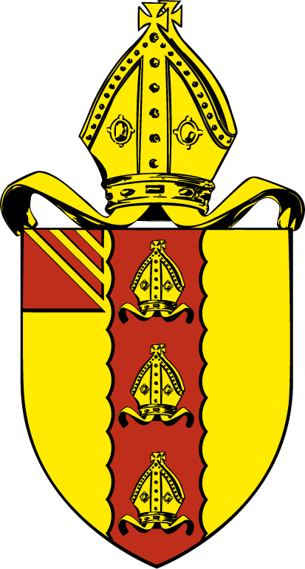

Diocese of Manchester Ember List 2011

PETERTIDE 2011

I ask for your prayers for these candidates and their Ministry in our Diocese.

Please pray that God the Holy Spirit will give them the gifts needed for service.

Pray too for their friends and families, and remember those others whom God is calling in the same way, praying that they may be ready to hear this call, and to prepare themselves to serve Christ in the ordained ministry of his Church.

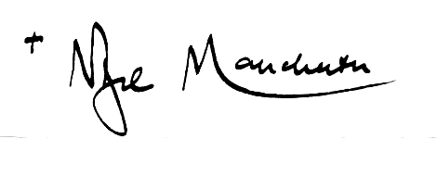

Almighty God,
we praise you for those whom you have called
to the ordained and accredited ministries
of your Church from age to age.
May they, whom you would use today, know your will;
give them understanding of the task that awaits them;
strengthen them as they fulfil your calling;
and keep them humble and faithful in your service;
for the glory of our Lord and Saviour,
Jesus Christ.
Amen.

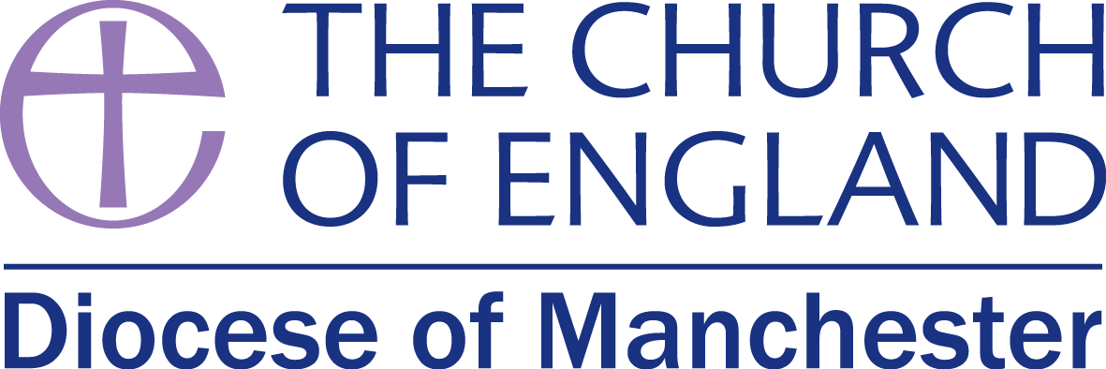
To be ordained Deacon by the Bishop of Manchester
in Manchester Cathedral on Sunday, 26 June 2011 at 10.30 a.m.

Rachel Damaris BATTERSHELL (Stipendiary)
The Southern North West Training Partnership to the Benefice of Holy Trinity, Coldhurst
and St. Stephen and All Martyrs, Lowermoor with the Revd. Nick Smeeton

Stephen BAZELY (Stipendiary)
Oak Hill Theological College to the Deane Team with the Revd. Dr. Terry Clark

Jacqueline (Jackie) CALOW (Stipendiary)
The Southern North West Training Partnership to the Parish of Langley with the
Revd. Canon Philip Miller

Gilbert DAVID (Stipendiary)
Cuddesdon to the Five Saints Team, New Bury with Great Lever with the Revd. Bob Horrocks, under the supervision of Revd Jenny Penn

Dorothy (Dot) FAIR (OLM)
The Southern North West Training Partnership at Holy Rood, Swinton with the Revd. Canon Chich Hewitt

James Nikolas GRANT (Stipendiary)
Westcott House to St. Clement, Chorlton-cum-Hardy with the Revd. Ken Flood

Jane GREENHALGH (OLM)
The Southern North West Training Partnership at the Five Saints Team, New Bury with Great Lever with the Revd. Bob Horrocks

Rhiannon JONES (Stipendiary)
Ridley Hall to Manchester Cathedral with the Revd. Canon Andrew Shanks

Alison OXBORROW (Stipendiary)
St. John’s College, Nottingham to St. James with Emmanuel, Didsbury with the Revd. Nick Bundock

________________________________________________________________________________
To be ordained Deacon by the Bishop of Beverley
On Thursday 30 June at 7.00 p.m.
At Christ Church, Chadderton

Christopher (Chris) EVANS (Stipendiary)
Oak Hill to Christ Church, Chadderton with the Revd. John Simmons

Please pray for Nicholas Munday who be serving in the Monmouth group of Parishes and Robert Brewis who will serve in the Ext Valley Mission Community

To be ordained Priest by the Bishop of Middleton
in Manchester Cathedral on Saturday, 18 June 2011 at 2.30 p.m.

Mark COWLING (Stipendiary)
Trinity College, Bristol at St. Peter, Halliwell with the Revd. Paul Hardingham

Peter James DEMAIN (OLM)
The Southern North West Training Partnership at the Middleton and Thornham Benefice
with the Revd. Canon Nick Feist

Elizabeth (Liz) Jane DEVALL (Stipendiary)
The Southern North West Training Partnership at St. Anne, Royton with the Revd. James Read

Revd. Jonathan ELCOCK (Stipendiary)
Westcott House at the Salford All Saints Team Ministry with the Revd. Mark Haworth

Barrie Stuart GASKELL (NSM)
The Southern North West Training Partnership at Bolton Parish Church with the
Revd. Matt Thompson and Royal Bolton Hospital with the Revd. Neil Gray

Christopher (Chris) Neville HARTLEY (OLM)
The Southern North West Training Partnership at St. Chrysostom, Victoria Park with the
Revd. Ian Gomersall

Andrea Susan JONES (Stipendiary)
The Southern North West Training Partnership (parish to be confirmed)

Pauline Edna JONES (OLM)
The Southern North West Training Partnership at the Parish of Langley with the
Revd. Canon Philip Miller

Janet Lesley LYSSEJKO (OLM)
The Southern North West Training Partnership at the United Benefice of Walmersley Road,
Bury with the Revd. Ian Stamp

Craig Lawrence ROTERS (Stipendiary)
The College of the Resurrection, Mirfield at St. Mary, High Crompton with the
Revd. Alan Butler

_________________________________________________________________________________
To be ordained Priest by the Bishop of Bolton
in Manchester Cathedral on Saturday, 18 June 2011 at 6.30 p.m.

Paul MATHOLE (Stipendiary)
Oak Hill College at Holy Trinity, Rusholme with the Revd. Steve James

William Howard MOSTON (OLM)
The Southern North West Training Partnership at St. James, East Crompton, with the
Revd. Lynne Connolly

Gillian (Gill) Fiona PAGE (Stipendiary)
Cranmer Hall, Durham at St. Luke and the Halliwell Team with the Revd. Stuart Cornes

Neil Christopher SHAVE (Stipendiary)
Westcott House, Cambridge at St. Margaret, Prestwich with the Revd. Debby Plummer

Catherine Jean SHELLEY (Stipendiary)
Westcott House, Cambridge at St. Paul, Kersal and St. Andrew, Carr Clough with the
Revd. Lisa Battye

Gareth Mark THOMAS (Stipendiary)
Cranmer Hall, Durham at Atherton, Hindsford & Howe Bridge with the
Revd. Canon Dr. Robert Buckley

Caroline Elizabeth THROUP (Stipendiary)
St. John’s, Nottingham at St. Margaret, Burnage with the Revd. Ian Thompson

Margaret Elizabeth YOUNG (NSM)
The Southern North West Training Partnership at St. Luke, Benchill (in the Wythenshawe Team)
with the Revd. Kaz Stanton

_______________________________________________________________
To be ordained Priest by the Bishop of Beverley on Sunday, 19 June 2011
at 3.00 p.m.
at St. Margaret, Hollinwood

Simon Benedict SAYER (Stipendiary)
St. Stephen’s House, Oxford at St. Margaret, Hollinwood and St. Chad, Limeside with the
Revd. David Hawthorn

Please also pray for the retreat conductors

For the Priests: Revd. Canon Anne Dyer

For the Deacons: Revd. Canon Felicity Lawson



